**Project Description**

**Requirement Gathering and Analysis:**

**1. Project Overview**

We are making a small web application to help manage vehicles and drivers.  
It will track when vehicles and drivers enter or leave the yard by scanning QR codes.  
The system will also save information about vehicles, drivers, and show basic reports.  
It will make sure that only the right people can see and edit the data.

**2. Goals and Objectives**

* Build a website to manage vehicles and drivers easily.
* Track check-in and check-out times using QR codes.
* Track vehicle movement in and out of the company gate using QR scanning.
* Show simple reports for how vehicles and drivers are being used.

**3. Scope of Work**

**Vehicle Management:**

* Add, edit, and delete vehicle details (like plate number, model, etc.).
* Create a unique QR code for each vehicle.
* Save extra details (like maintenance and insurance records).

**Driver Management:**

* Add, edit, and delete driver details (like name, contact, license number).
* Link drivers to vehicles.

**Time Tracking (QR Code Based):**

* Allow scanning of QR codes through a phone or computer camera.
* Save the time when a vehicle or driver checks in and out.
* Keep track of which driver and which vehicle.

**Yard Entry/Exit Tracking:**

* Scan QR codes at the gate to track vehicle entry and exit.
* Record time and driver/vehicle information.

**Reporting:**

* Create simple reports like:
  + How much a vehicle was used (hours, trips, mileage, fuel).
  + How much a driver drove.
  + Time in and out records.
  + Yard entry/exit logs.
* Create a dashboard showing important numbers.

**4. Front end:**

We are building it’s front end in react.

**4. Back end:**

The back end of this project is being built in node.

**6. Database:**

PostgreSQL is used as a database.

**Database schema:**

Below is the relational schema of each entity,

Driver: (**driver_id** PK , role_id FK, name, contact, license number)

Vehicle: (**vehicle_id** PK, license plate, make, model, year, maintenance records, insurance expiry)

DriverVehicleAssignment: (assignment_id PK, driver_id FK, vehicle_id FK, assigned_date)

TimeLog: (timelog_id PK, driver_id FK, vehicle_id FK, check_in_time, check_out_time)

YardLog: (yardlog_id PK, vehicle_id FK, user_id FK, entry_time, exit_time)

User: (user_id PK, username, password_hash, role_id FK, email, contact_number)

Role :(role_id PK, role_name)

**Server Setup:**

The initial server is already setup with initial front end.

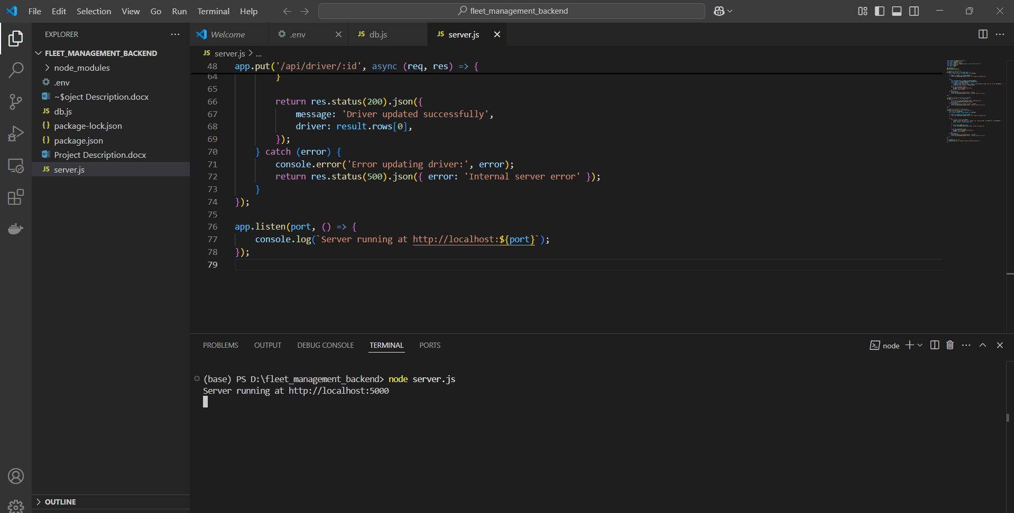

**Initial API endpoint:**

An initial api endpoint is built which is send http post request from front end to back end.

Initial Front-end setup:

The initial front-end setup is also built, and initial UI component are also built.

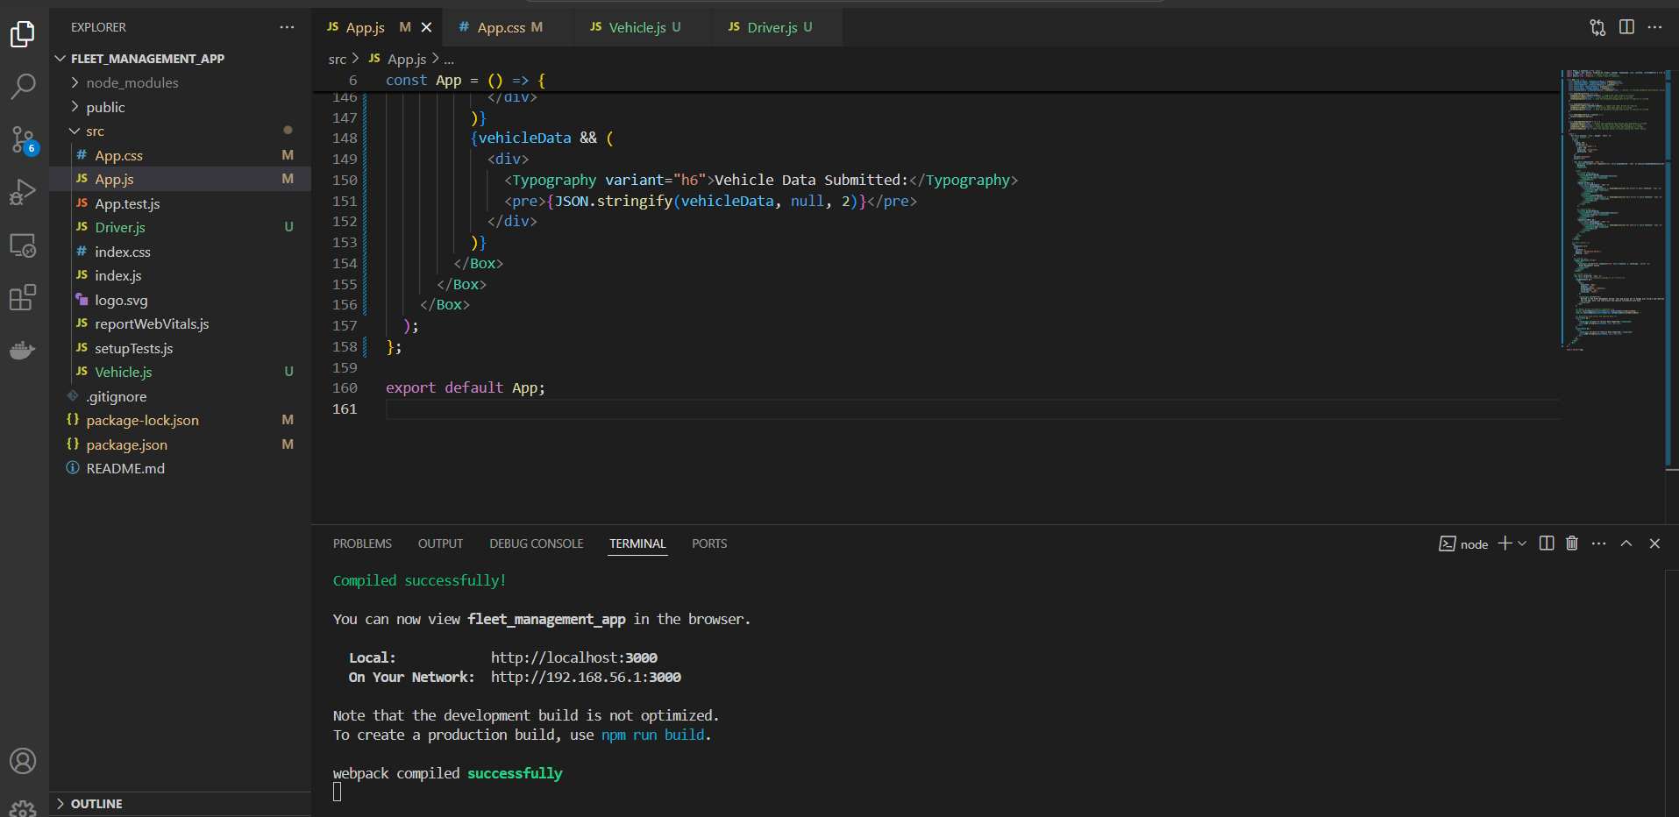

Basic UI:

Below are some screenshots of basic UI,

The designs and theme of the app is not finalized yet so it will be changing as per the requirements and as the project goes forward.